Install Nagios 4.3.2 on Ubuntu 16.04:

Prerequisites:

Nagios 4.3.2 is the latest version at the time of writing,  before compiling the Nagios from the source; you need to install dependent packages for Nagios to work.

PS: Get the Latest version of Nagios from the [official page](https://www.nagios.org/downloads/core-stay-informed/" \t "_blank).

Let’s switch to root user.

sudo su

Update the repository cache and install the dependencies for Nagios 4.

|  |
| --- |
| apt-get update apt-get install build-essential apache2 php7.0 openssl perl make php7.0-gd libgd2-xpm-dev libapache2-mod-php7.0 libperl-dev libssl-dev daemon wget apache2-utils unzip |

Create nagios user and nagcmd group (allowing the external commands to be executed through the web interface), add the nagios and apache user to the part of the nagcmd group.

useradd nagios groupadd nagcmd usermod -a -G nagcmd nagios usermod -a -G nagcmd www-data cd /tmp wget https://assets.nagios.com/downloads/nagioscore/releases/nagios-4.3.2.tar.gz tar -zxvf nagios-4.3.2.tar.gz cd /tmp/nagios-4.3.2/

Compile and Install Nagios:

Perform below steps to compile the Nagios from the source code.

./configure --with-nagios-group=nagios --with-command-group=nagcmd --with-httpd\_conf=/etc/apache2/sites-enabled/ make all make install make install-init make install-config make install-commandmode make install-webconf

Configure Nagios:

Configuration files have now been placed by the installer in the /usr/local/nagios/etc directory. These default configuration files should work fine for now to start Nagios.  All you need to make just one change before you proceed…

Edit the /usr/local/nagios/etc/objects/contacts.cfg config file and change the email address associated with the nagiosadmin contact definition to the address you’d like to use for receiving alerts.

vi /usr/local/nagios/etc/objects/contacts.cfg

Change the email address field to receive the notification.

define contact{         contact\_name                    nagiosadmin             ; Short name of user         use                             generic-contact         ; Inherit default values from generic-contact template (defined above)         alias                           Nagios Admin            ; Full name of user         email                           nagios@itzgeek.com      ; <<\*\*\*\*\* CHANGE THIS TO YOUR EMAIL ADDRESS \*\*\*\*\*\*         }

Configure Web Interface:

Create a user account (nagiosadmin) for logging into the Nagios web interface. Remember the password you assign to this account – you’ll need it later.

htpasswd -c /usr/local/nagios/etc/htpasswd.users nagiosadmin

Run the following command.

a2enmod cgi

Restart Apache to make the new settings take effect.

service apache2 restart

Download and Install Nagios Plugins:

Now, it’s time to download Nagios plugins for monitoring the services. Place it into /tmp directory.

cd /tmp wget https://nagios-plugins.org/download/nagios-plugins-2.2.1.tar.gz tar -zxvf /tmp/nagios-plugins-2.2.1.tar.gz cd /tmp/nagios-plugins-2.2.1/

Compile and install the plugins.

./configure --with-nagios-user=nagios --with-nagios-group=nagios make make install

Starting Nagios:

Verify the sample Nagios configuration files.

/usr/local/nagios/bin/nagios -v /usr/local/nagios/etc/nagios.cfg

Ubuntu 16.04 uses systemd for starting / stopping all the services, so, we need to create nagios.service file.

vi /etc/systemd/system/nagios.service

Add below content into above file.

[Unit] Description=Nagios BindTo=network.target [Install] WantedBy=multi-user.target [Service] User=nagios Group=nagios Type=simple ExecStart=/usr/local/nagios/bin/nagios /usr/local/nagios/etc/nagios.cfg

Enable Nagios to start automatically at system startup.

systemctl enable /etc/systemd/system/nagios.service

Now, start Nagios service.

systemctl start nagios

Access Web Interface:

Now access the Nagios web interface using the following URL. You’ll be prompted for the username (nagiosadmin) and password you specified earlier.

http://ip-address/nagios/

[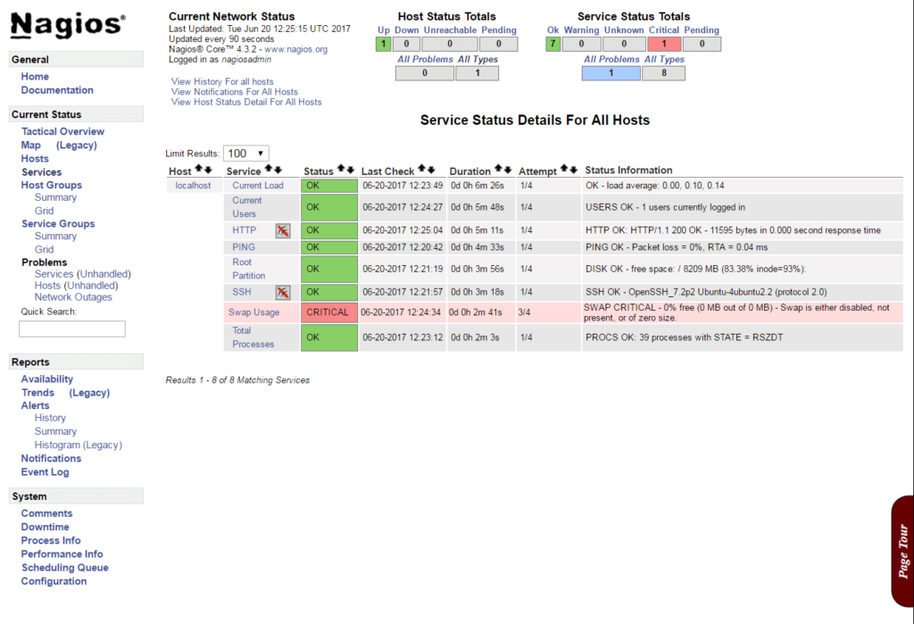](http://cdn.itzgeek.com/wp-content/uploads/2016/06/Install-Nagios-4.3.2-on-Ubuntu-16.04-Services-status.png)Install Nagios 4.3.2 on Ubuntu 16.04 – Services status

Source: http://www.itzgeek.com/how-tos/linux/ubuntu-how-tos/install-nagios-4-1-1-ubuntu-16-04.html